**Name: Pratham Shah**

**Reg No: 221070061**

**Batch C – SY Comps**

**PL Lab**

**Experiment 7:**

**Aim:**

Write an application to implement client-server programming

**Theory:**

Socket Programming is a way of connecting two nodes on a network to communicate with each other. One socket (node) listens on a particular port at an IP, while the other socket reaches out to the other to form a connection. The server forms the listener socket while the client reaches out to the server.

They are the real backbones behind web browsing. In simpler terms, there is a server and a client.

Socket programming is started by importing the socket library and making a simple socket.\

A server is a software that waits for client requests and serves or processes them accordingly.

A client is a requester of this service.

A client programs a request for some resources to the server and the server responds to that request. Socket is the endpoint of a bidirectional communications channel between server and client. Sockets may communicate within a process, between processes on the same machine, or between processes on different machines. For any communication with a remote program, we have to connect through a socket port.

**Client Code:**

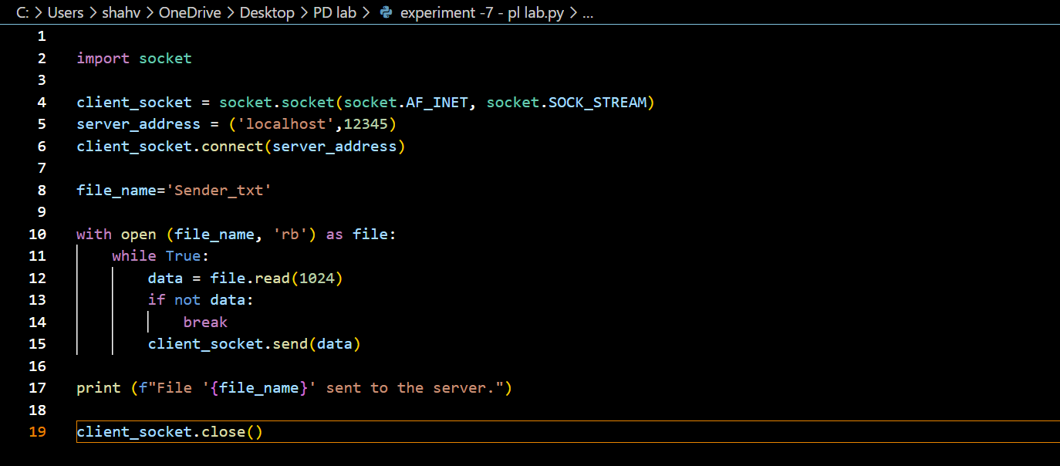

**Server Code:**

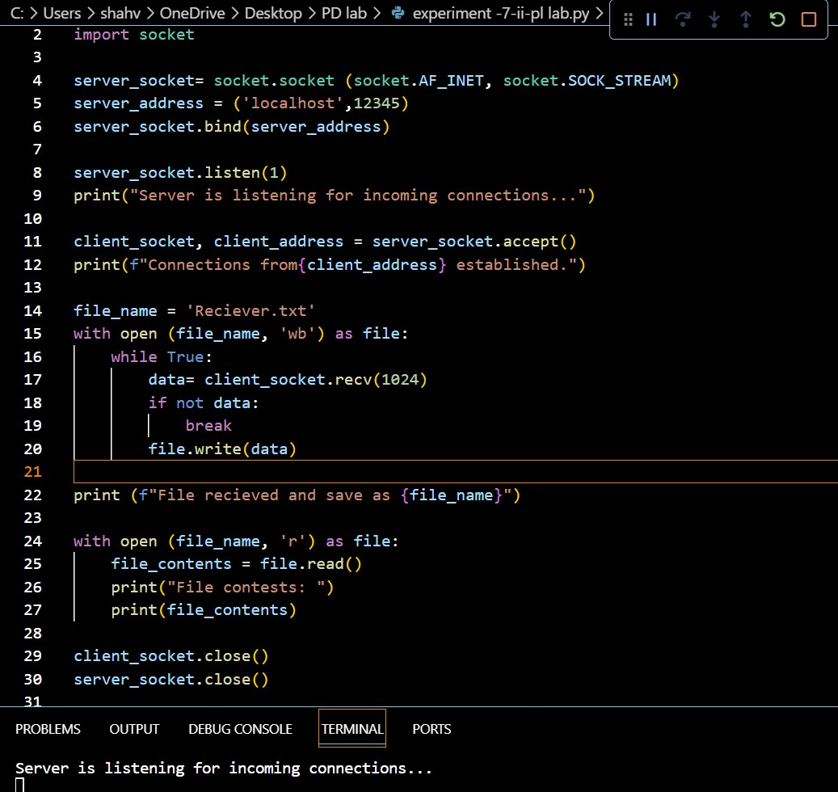

**Conclusion:**

Conclusion: Thus, with the help of this experiment, we have learnt, how the client, server individually works, and how the message sent by the client is received by the server